Questions and Exercises to work out and turn in:

Grading Guidelines:

* A right answer will get full credit when:

1. It is right (worth 25%)
2. It is right **AND** neatly presented making it easy and pleasant to read. (worth an **extra** 15%)
3. There is an **obvious and clear link** between 1) the information provided in the exercise and in class and 2) the final answer. A clear link is built by properly writing, justifying, and documenting an answer (worth an **extra** 60%).
4. Calculation mistakes will be minimally penalized (2 to 5% of full credit) while errors on units will be more heavily penalized.

You are welcome/encouraged to discuss exercises with other students or the instructor. But, ultimately, **personal** writing is expected.

* USE THIS FILE AS THE STARTING DOCUMENT YOU WILL TURN IN. **DO NOT DELETE ANYTHING FROM THIS FILE:** JUST **INSERT** EACH ANSWER **RIGHT AFTER ITS QUESTION/PROMPT**.
* IF USING HAND WRITING (STRONGLY DISCOURAGED), **USE THIS FILE** BY CREATING SUFFICIENT SPACE AND WRITE IN YOUR ANSWERS.
* FAILING TO FOLLOW TURN IN DIRECTIONS /GUIDELINES WILL COST **A 30% PENALTY.**

**Objectives of this assignment**:

* to use and manipulate the concepts presented in this module
* to propose and write algorithms in pseudocode
* to analyze the time complexity of algorithms
* to analyze the space complexity of algorithms
* to learn autonomously new concepts

What you need to do:

Answer the questions and/or solve the exercises described below.

Exercise 1 (50 points) Kruskal’s Algorithm

Consider this graph G=(V, E, w) provided as an adjacency-matrix. V = (r, s, t, u, v, w, x, y)

|  |  |  |  |  |  |  |  |  |
| --- | --- | --- | --- | --- | --- | --- | --- | --- |
|  | r | s | t | u | v | w | x | y |
| r |  | 13 | 17 |  |  |  |  |  |
| s | 13 |  |  | 16 |  |  |  |  |
| t | 17 |  |  | 19 |  |  |  |  |
| u |  | 16 | 19 |  | 21 | 26 |  |  |
| v |  |  |  | 21 |  | 17 | 13 |  |
| w |  |  |  | 26 | 17 |  | 17 |  |
| x |  |  |  |  | 13 | 17 |  |  |
| y |  |  |  |  |  |  |  |  |

1. (5 points) Draw this graph. If needed, you can draw by hand, take a picture and insert it. Just make sure the drawing is neat and pleasant (neatness is worth 15%)
2. (45 points) Trace **Kruskal’s** algorithm and **show step by the step** the construction of the minimum spanning tree. **Draw** the MST each time you add an edge. **Highlight** the latest added edge with its weight.

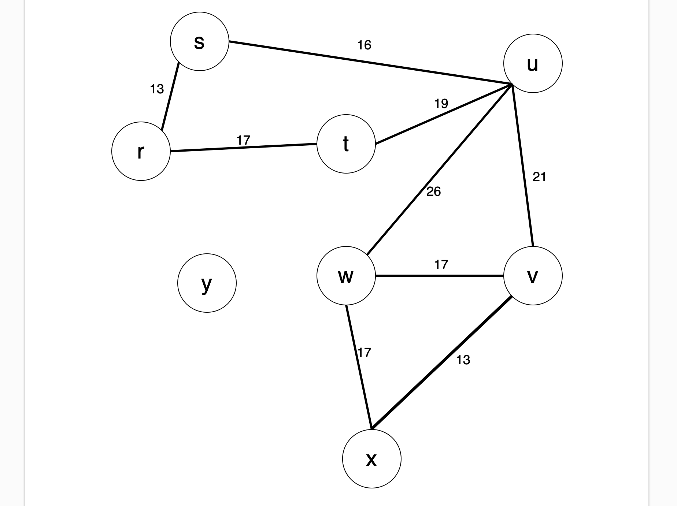

Exercise 2 (50 points) Prim’s Algorithm

Consider this graph G=(V, E, w) provided as an adjacency-matrix. V = (r, s, t, u, v, w, x, y)

|  |  |  |  |  |  |  |  |  |
| --- | --- | --- | --- | --- | --- | --- | --- | --- |
|  | r | s | t | u | v | w | x | y |
| r |  | 13 | 17 |  |  |  |  |  |
| s | 13 |  |  | 16 |  |  |  |  |
| t | 17 |  |  | 19 |  |  |  |  |
| u |  | 16 | 19 |  | 21 | 26 |  |  |
| v |  |  |  | 21 |  | 17 | 13 |  |
| w |  |  |  | 26 | 17 |  | 17 |  |
| x |  |  |  |  | 13 | 17 |  |  |
| y |  |  |  |  |  |  |  |  |

1. Draw this graph (It is the same as the previous question. Copy/Paste would be just fine).
2. (45 points) Trace **Prim’s** algorithm starting from Vertex and **show step by the step** the construction of the minimum spanning tree. **Draw** the MST each time you add an edge. **Highlight** the latest added edge with each weight.
3. (5 points) **Compare** the minimum spanning trees obtained by Kruskal’s and Prim’s algorithms, respectively.

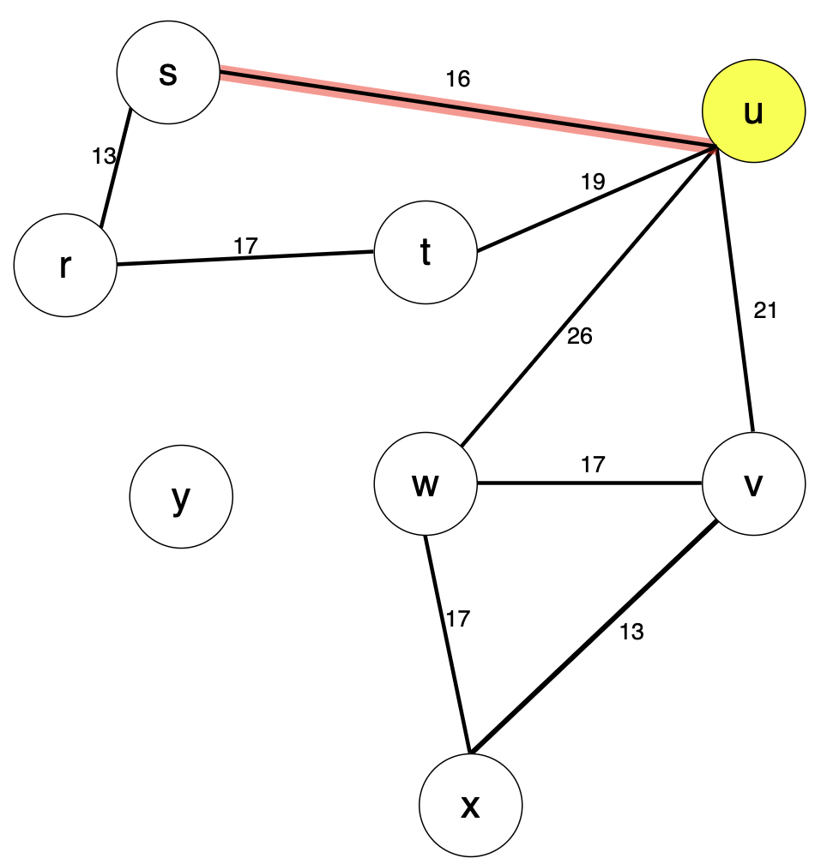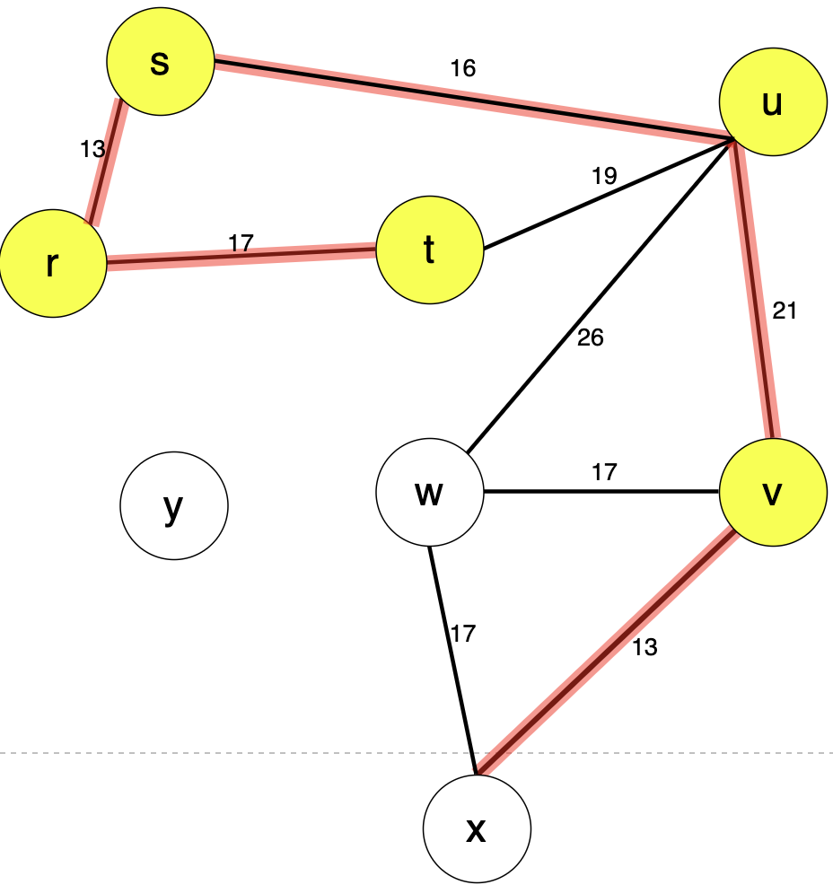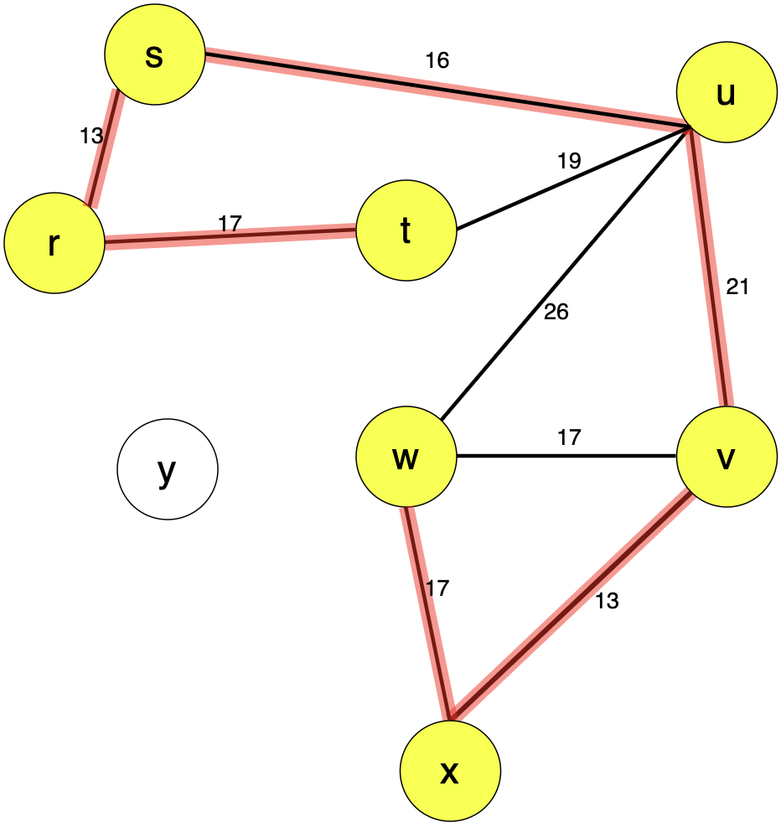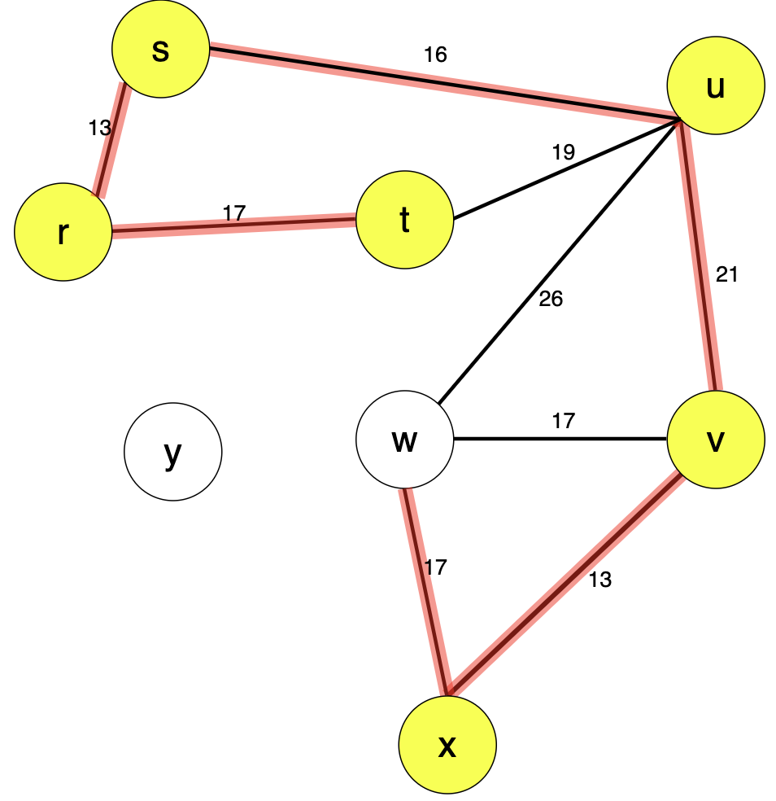

**What you need to turn in:**

* Electronic copy of this file (including your answers) (standalone). Submit the file as a Microsoft Word or PDF file.
* Recall that answers must be well written, documented, justified, and presented to get full credit.
* How this assignment will be graded:
* A right answer will get full credit when:
* It is right (worth 25%)
* It is right AND neatly presented making it easy and pleasant to read. (worth 15%)
* There is an obvious and clear link between 1) the information provided in the exercise and in class and 2) the final answer. A clear link is built by properly writing, justifying, and documenting an answer (worth 60%).
* Calculation mistakes will be minimally penalized (2 to 5% of full credit) while errors on units will be more heavily penalized.
* You are welcome/encouraged to discuss exercises with other students or the instructor. But, ultimately, personal writing is expected.

**Appendix**: Grading: What is an OBVIOUS and CLEAR LINK?

Here is an example to explain what an **obvious and clear link** is and how we grade your work.

Consider the following problem:

"(100 points) John travels from Auburn to Atlanta in his car at a speed of 60 mph. Leaving at 8am, at what time will John reach Atlanta".

Here are the answers of three students and their scores:

* **Student 1** answers: "9:48am". Student 1 will get 25 points.
* **Student 2**answers : "John will reach Atlanta at 9:48am". Student 2 will get 25+15 = 40 points
* **Student 3** answers: "The time t to travel a distance d at speed v is equal to d/v = d/60mph. The problem does not provide the distance d from Auburn to Atlanta. Based on GoogleMaps, the distance from Auburn to Atlanta is approximately 108 miles (**document is attached**).

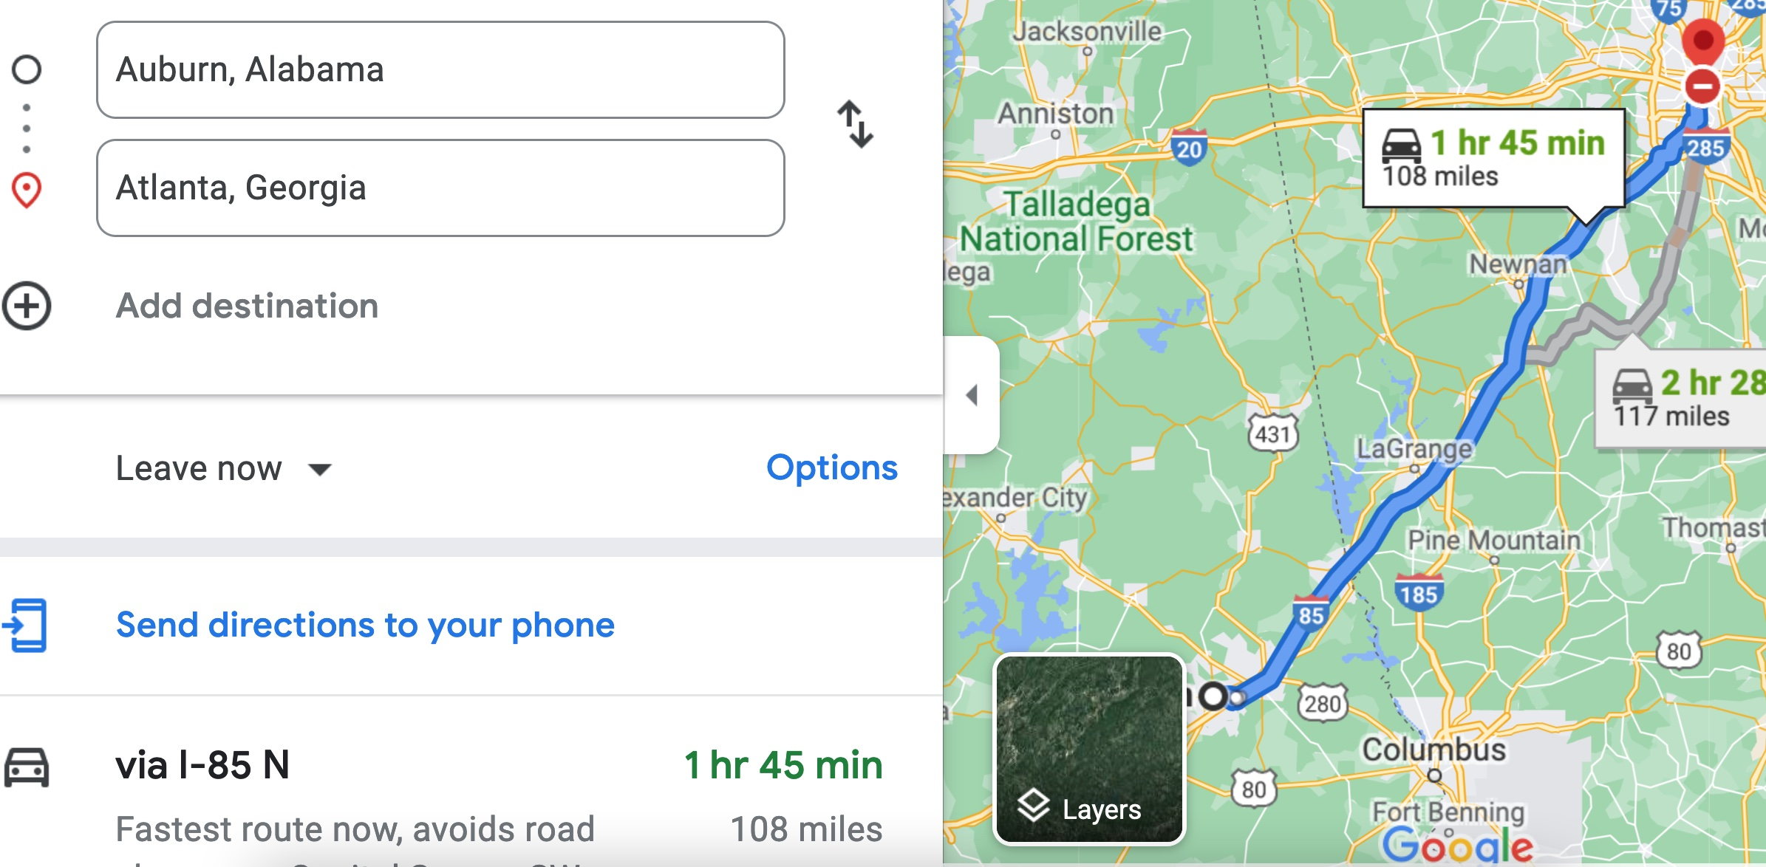

Therefore, the time t = 108 miles/60mph * 60 minutes/hour= 108 minutes. Since John left at 8am, he will then reach Atlanta at 8am + 108 minutes = 8 am + 60 minutes + 48 minutes = 9:48".

**Student 3** will get 25 + 15 + 60 = 100 points

Do you see the **direct** **link** going from the data provided in the question to the final answer, using general knowledge/formula and documents?.... Can you now solve the following problem and get 100 points?

"(100 points) Alice travels from Auburn to Atlanta in her car at a speed of 60 mph. Leaving at 8am, at what time will Alice reach Atlanta assuming that she had a flat tire that delayed her 30 minutes".